/*

**Problem 1:**

Show the count of table regions and the count of table countries (2 SQL statements).

Now create a Cartesian Join between tables regions and countries and display the following columns:

➢ region_name

➢ country_name

Order the resulting data set by region_name and country_name.

Deliverables: 3 queries

*/

1.

SELECT Count(*) FROM regions ;

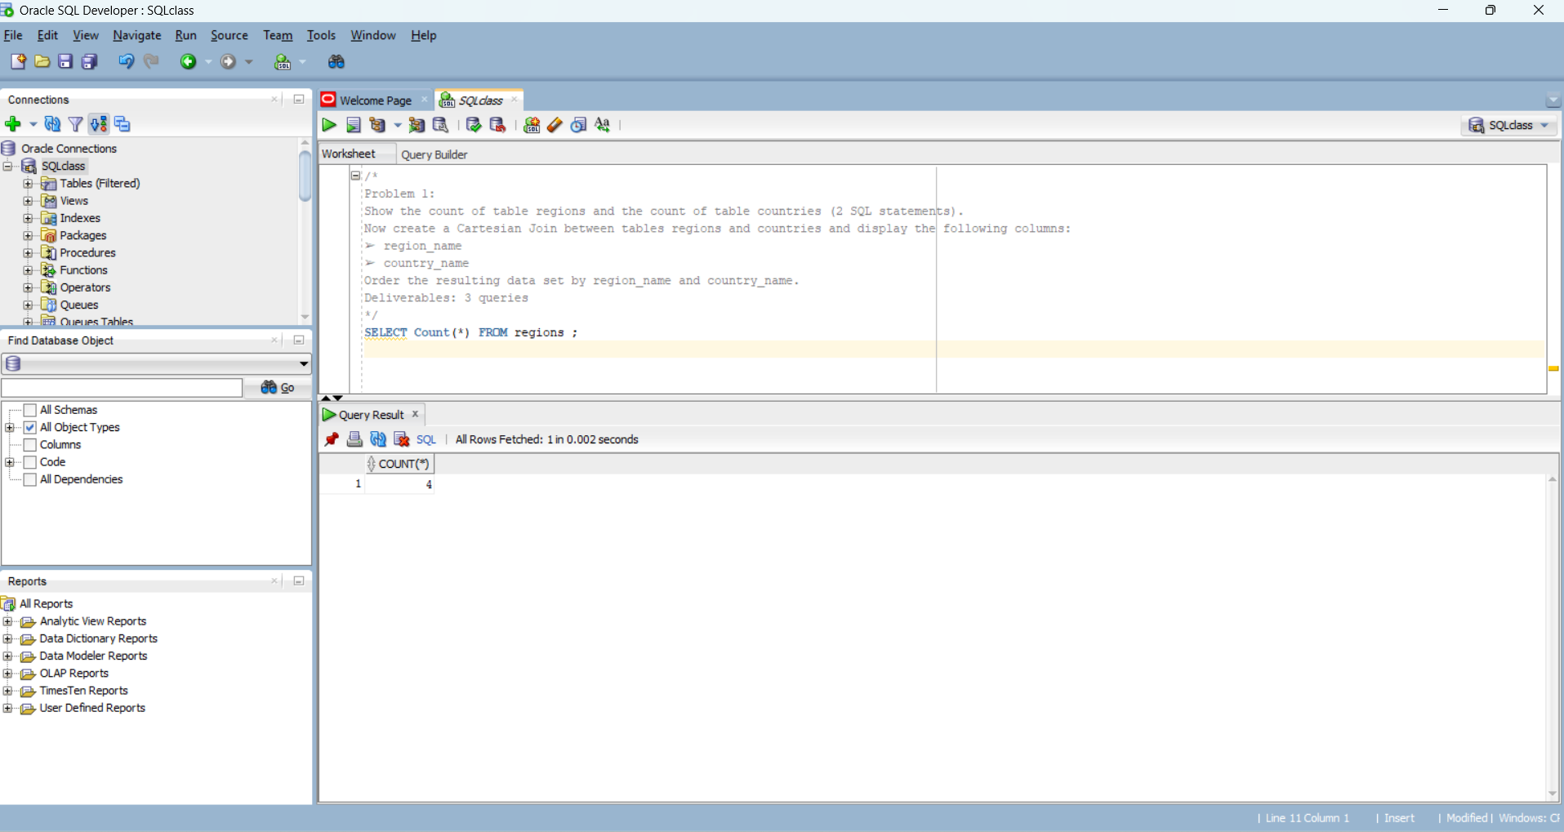

2.

SELECT Count(*) FROM countries;

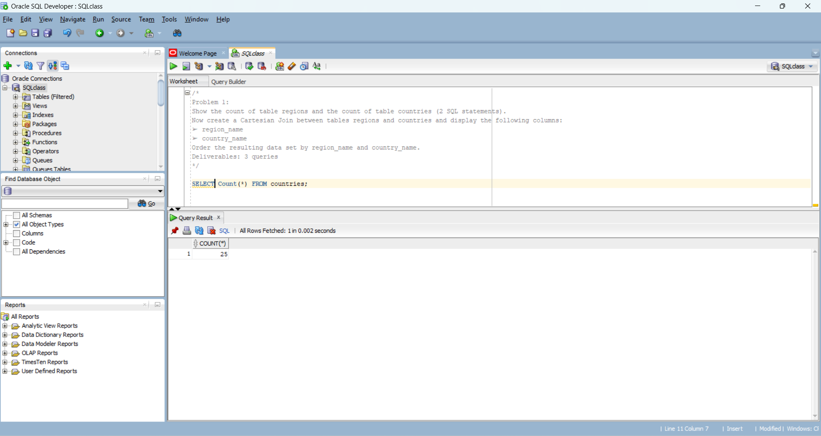

3.

SELECT region_name, country_name

FROM regions, countries

ORDER BY region_name, country_name;

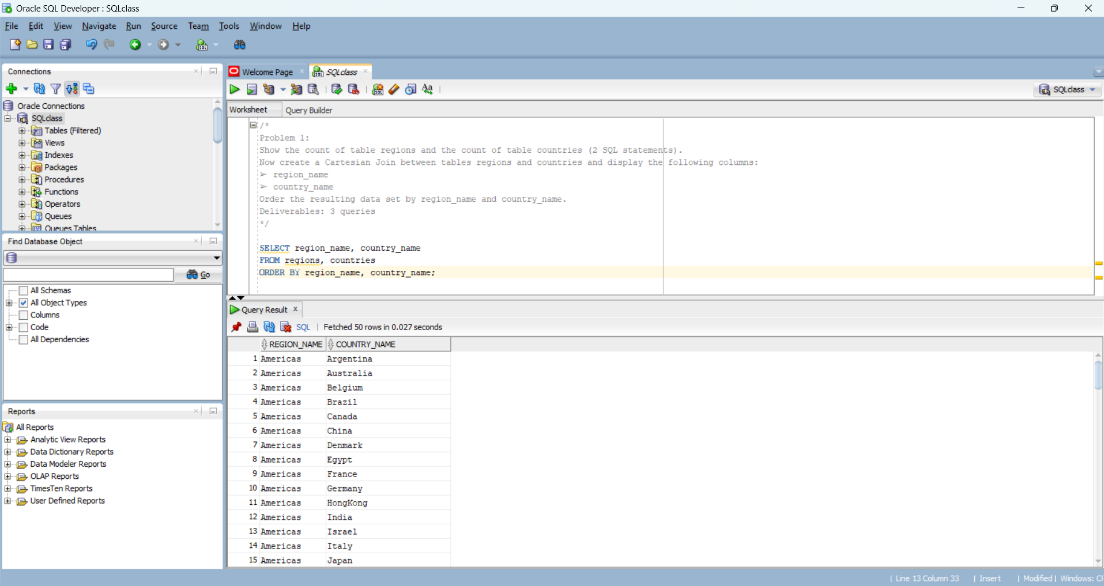

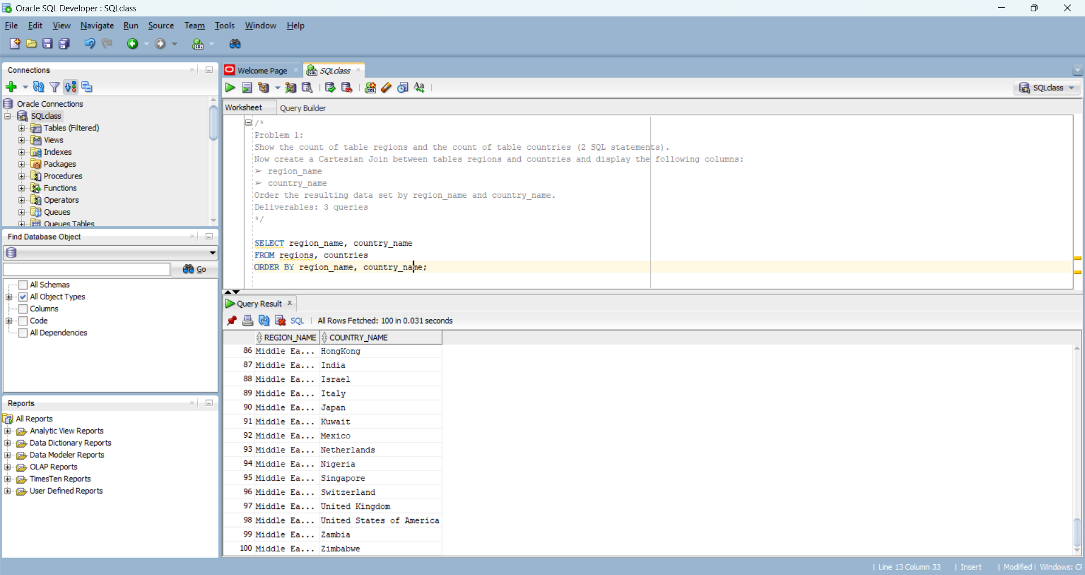

/*

**Problem 2:**

Using the same requirements from problem 1, now instead of the Cartesian Join create an Inner Join between tables

regions and countries using the INNER JOIN syntax.

Deliverables: One query

*/

SELECT R.region_name, C.country_name

FROM regions R INNER JOIN countries C ON r.region_id = C.region_id

ORDER BY R.region_name, C.country_name; 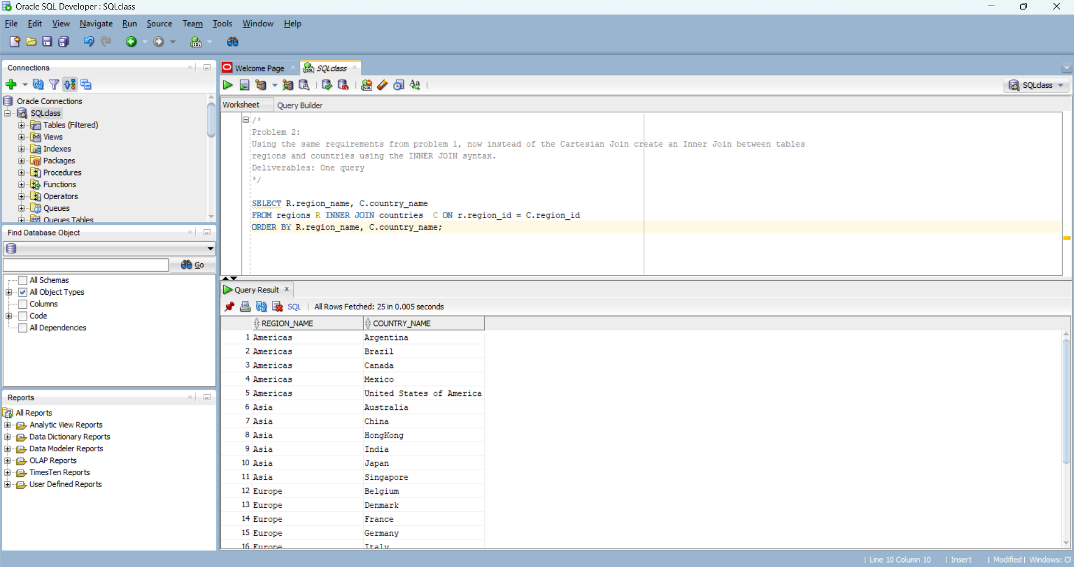

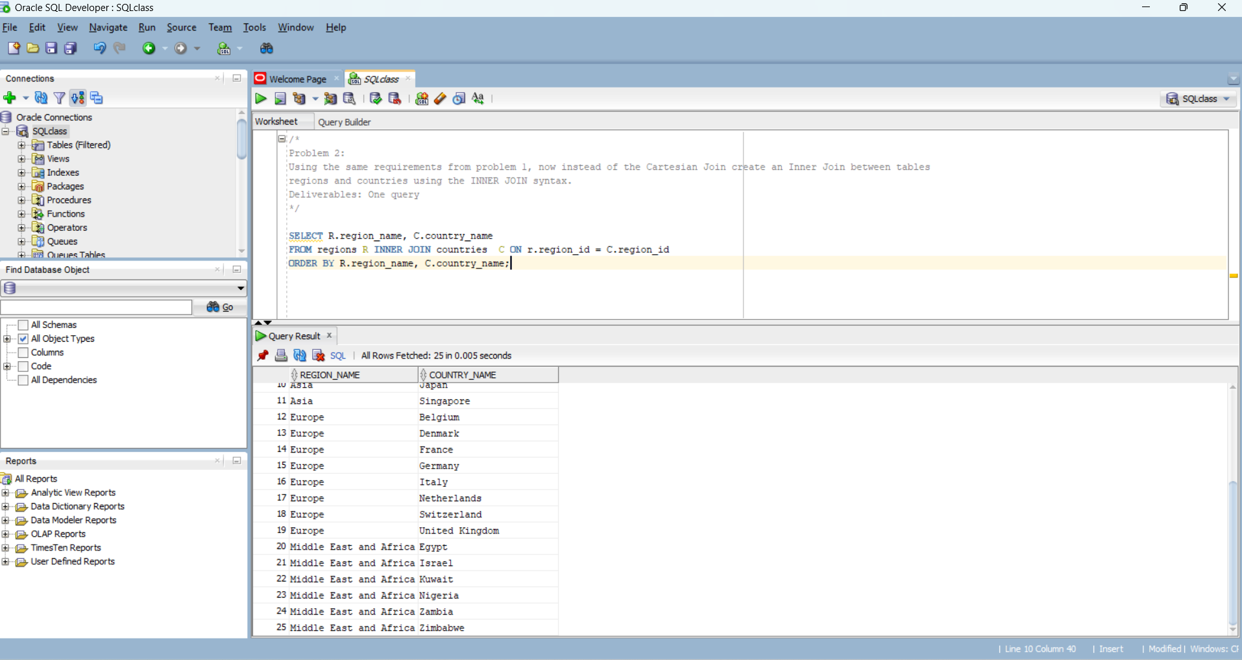

/*

**Problem 3:**

Create a left and right outer join (separate queries) between tables countries and locations and display the following

columns:

➢ country_id

➢ country_name

➢ city

➢ state_province

Order the resulting data set by country_name and city.

Deliverables: 2 queries

*/

1.

SELECT c.country_id, c.country_name,l.city, l.state_province

FROM countries c LEFT OUTER JOIN locations l ON c.country_id = l.country_id

ORDER BY c.country_name, l.city;

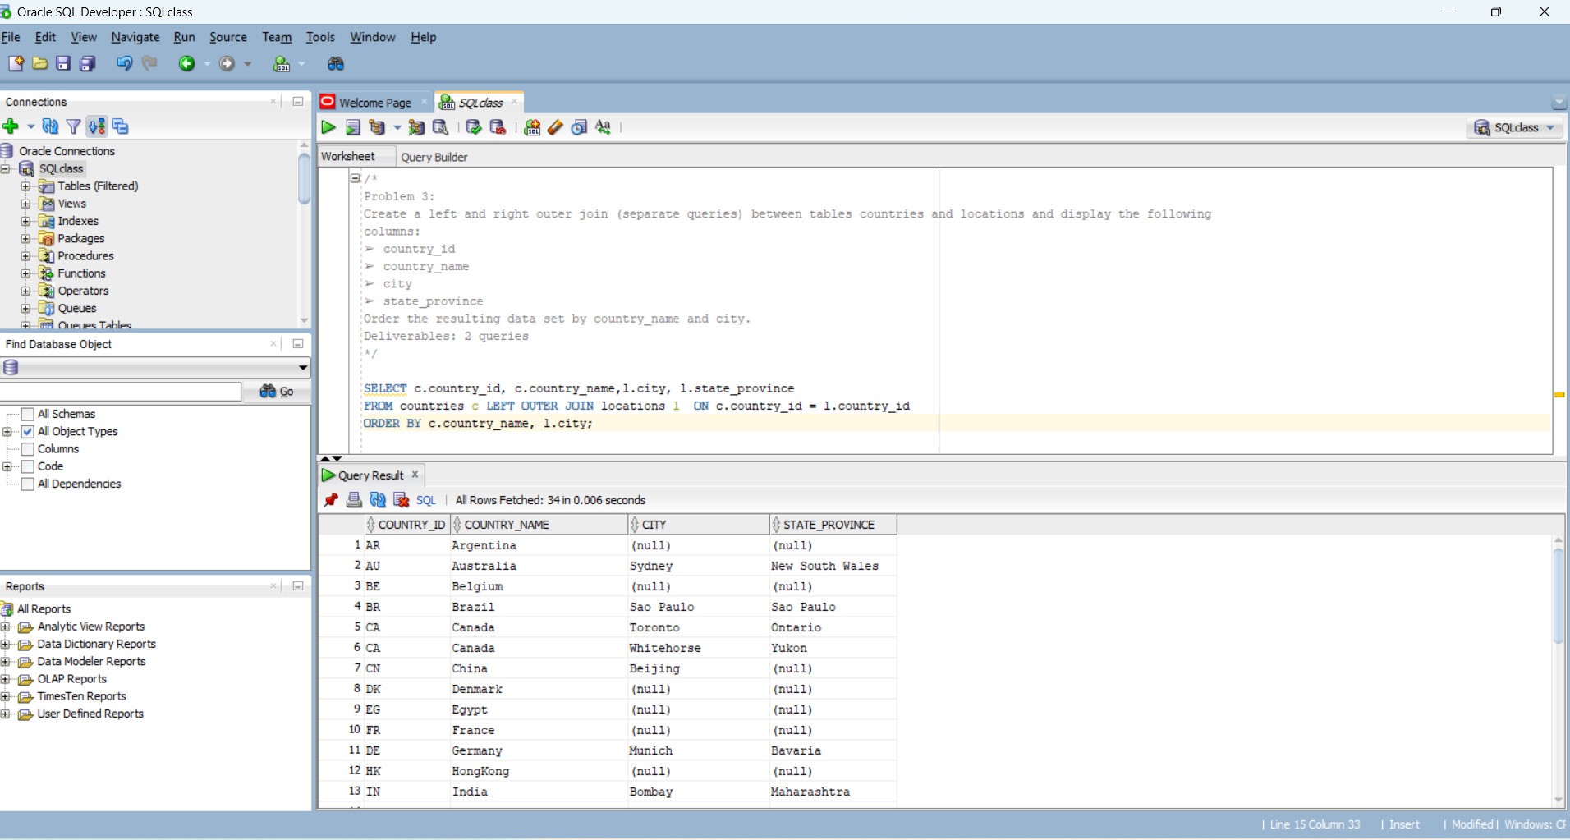

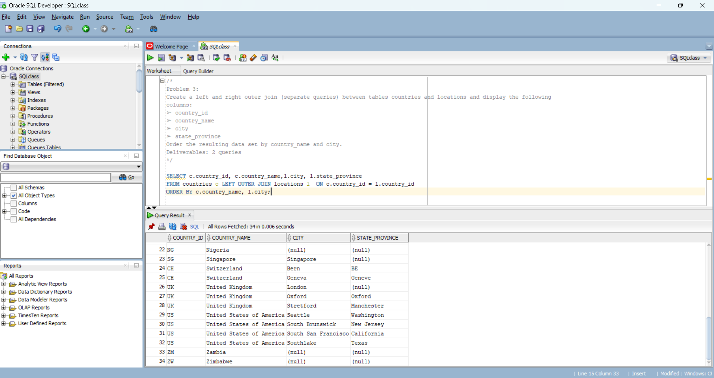

2.

SELECT c.country_id, c.country_name,l.city, l.state_province

FROM countries c RIGHT OUTER JOIN locations l ON c.country_id = l.country_id

ORDER BY c.country_name, l.city;

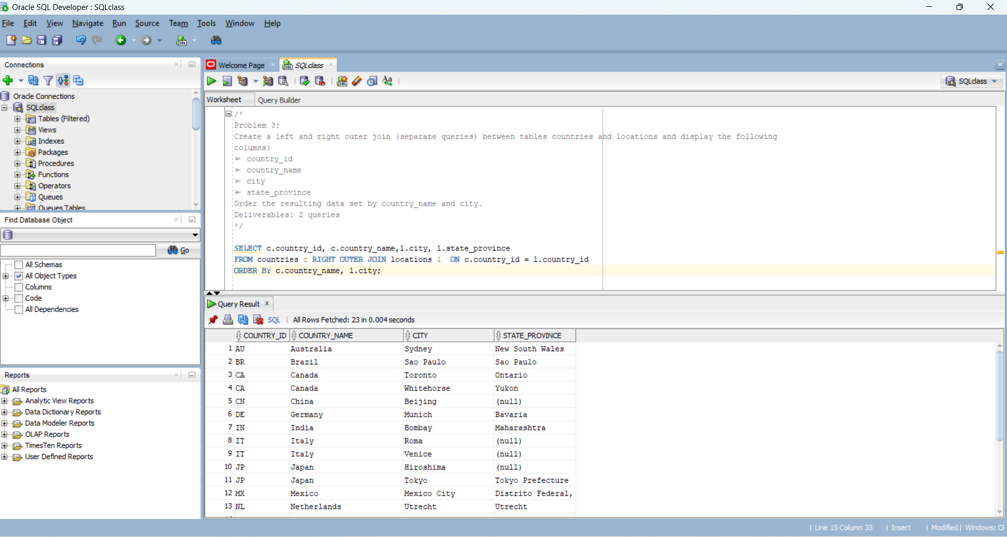

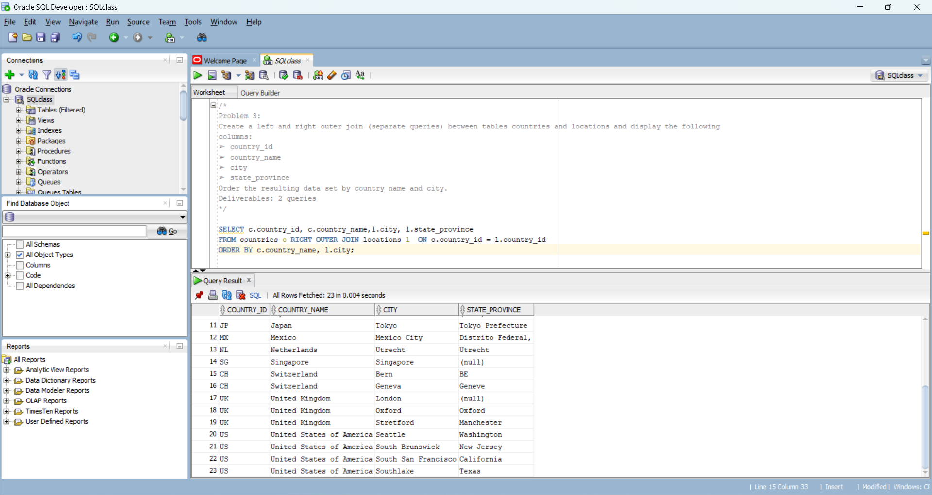

/*

**Problem 4:**

A. Create a query joining table employees and departments on column department_id using the USING clause. Display

the following columns:

➢ employee_id

➢ Expression: last_name concatenated with a comma and blank space and first_name aliased as fullname

➢ department_name

Limit the output to department names starting with P. Sort the resulting dataset by department_name and fullname.

B. Now using the same query just change the join to a NATURAL JOIN.

C. Explain the differences in the output in one or two sentences.

Deliverables: 2 queries (A and B) and one explanation(C)

*/

A.

SELECT e.employee_id, e.last_name || ', ' || e.first_name AS "fullname", d.department_name

FROM employees e INNER JOIN departments d USING (department_id)

WHERE d.department_name LIKE 'P%'

ORDER BY d.department_name, "fullname" ;

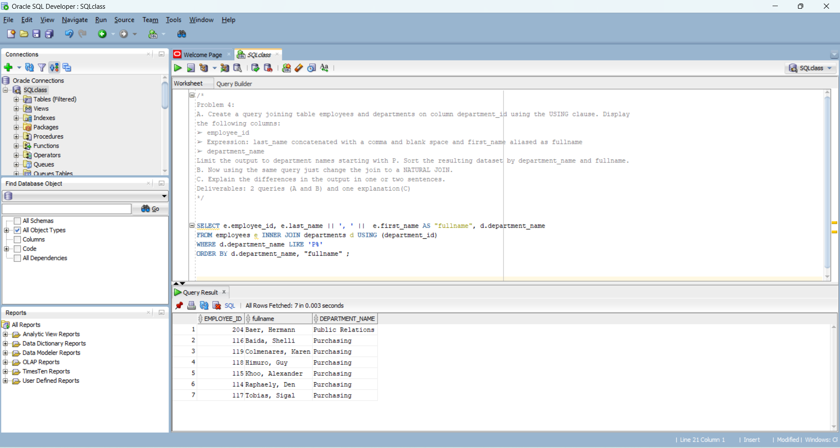

B.

SELECT e.employee_id, e.last_name || ', ' || e.first_name AS "fullname", d.department_name

FROM employees e NATURAL JOIN departments d

WHERE d.department_name LIKE 'P%'

ORDER BY d.department_name, "fullname" ;

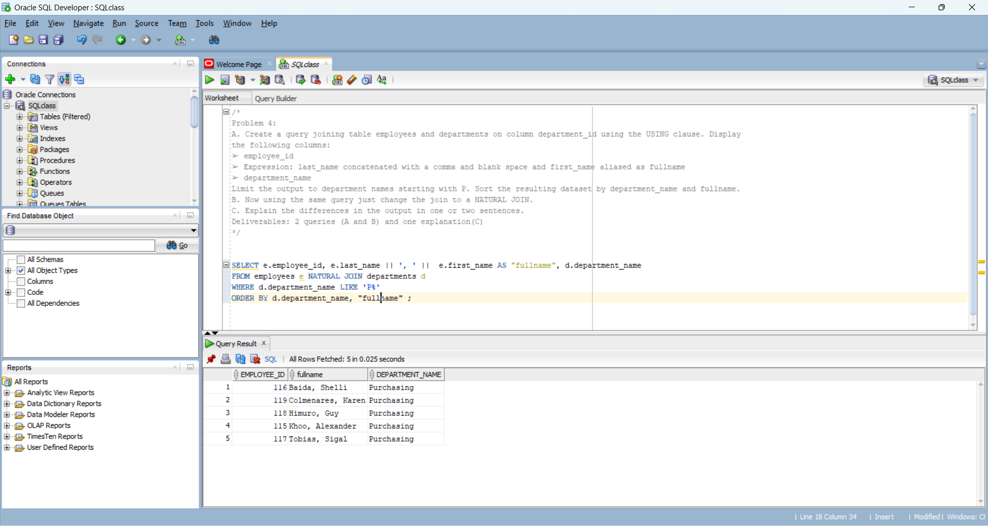

C.

Since the common column names in both table employees and table departments are “department_id” and “manager_id”, they are the basis being used to link the tables when NATURAL JOIN is used compared to USING keyword where tables are linked on “department_id” only.

The result of using NATURAL JOIN is equivalent to using

USING (department_id, manager_id).

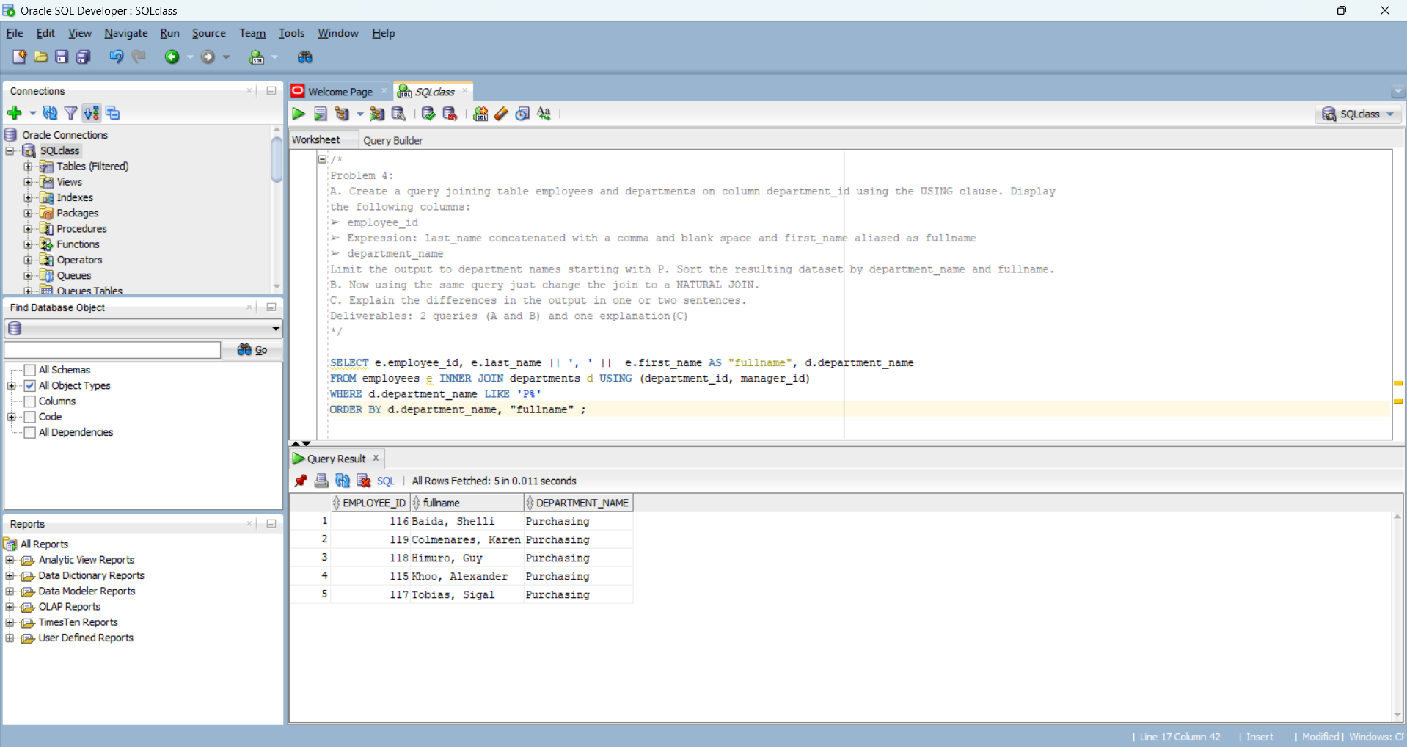

/*

**Problem 5:**

Create a query showing the department_name from table departments, last_name from table employees, and job_title

from table jobs. Ensure to display ALL department_name values from table departments, not only the matching ones.

Sort the resulting data set by department_name and last_name.

Deliverables: One query

*/

SELECT d.department_name, e.last_name, j.job_title, d.department_id

FROM departments d LEFT OUTER JOIN employees e ON d.department_id = e.department_id

LEFT OUTER JOIN jobs j ON e.job_id = j.job_id

ORDER BY d.department_name, e.last_name;

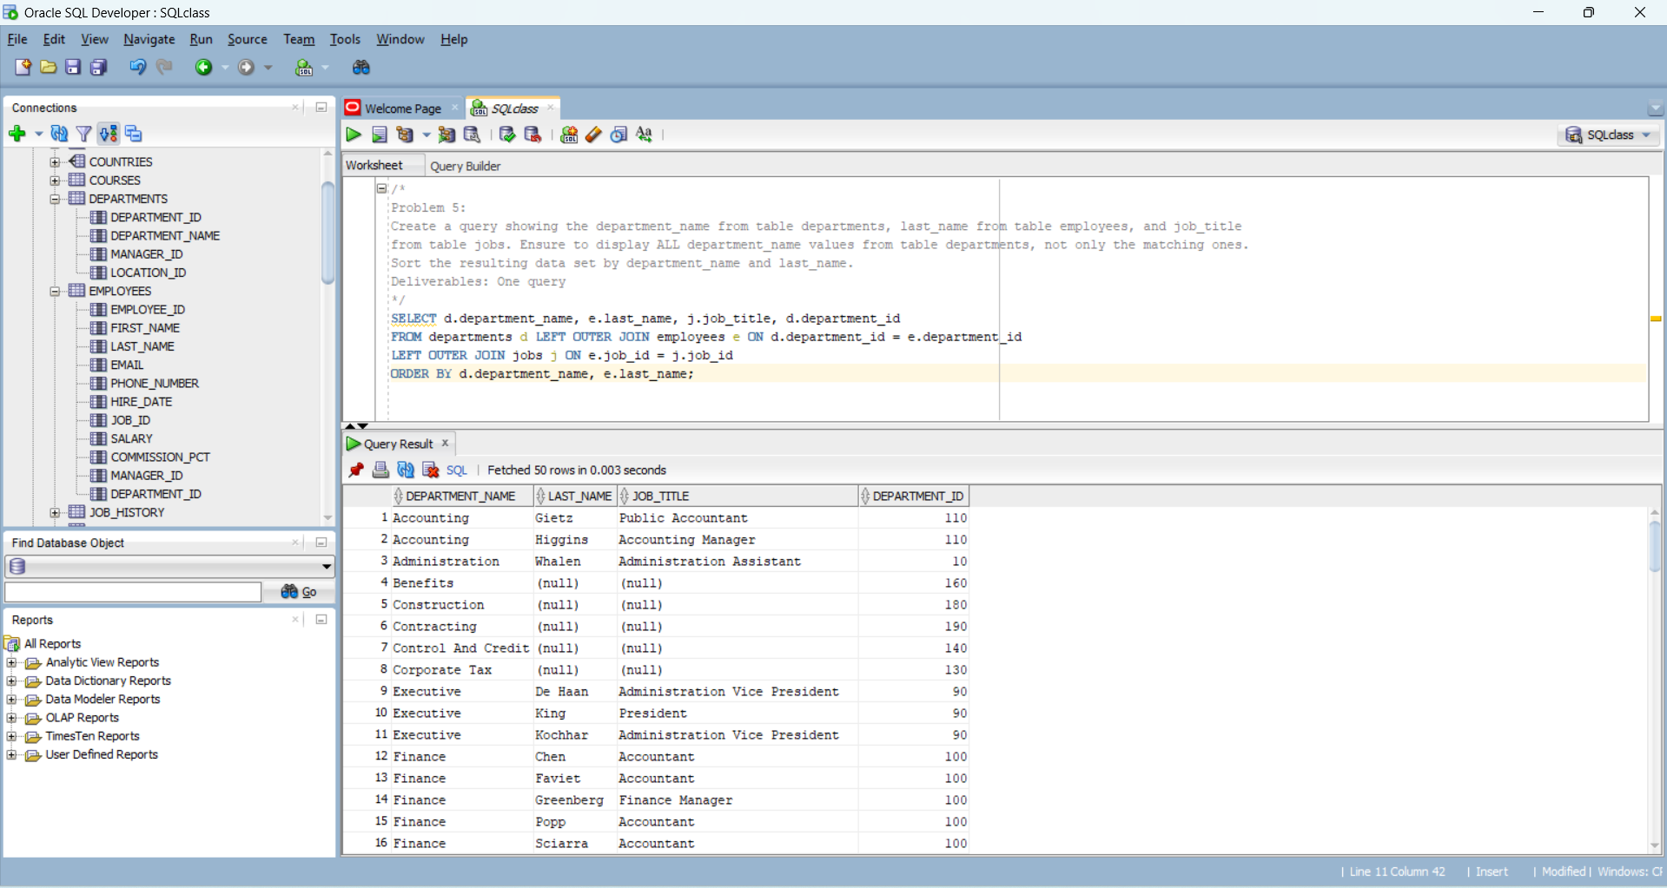

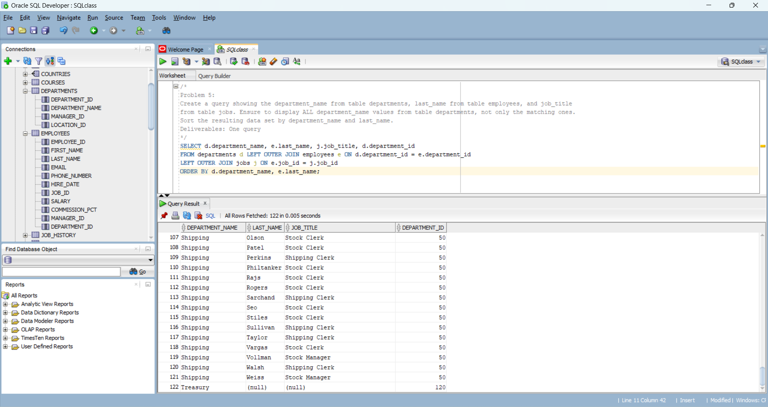

/*

**Problem 6:**

Create a query joining table departments with the employees twice. Create one Inner Join on the columns

department_id (between table departments and employees using alias e) and the other Inner Join on manager_id

(departments) and employee_id (employees using alias m). Display the following columns:

➢ Expression: last_name and a comma and blank space and then first_name, alias this column Employee

➢ Department_name

➢ Expression: first_name and a blank space and then last_name, alias this column with Manager

Order the resulting data set by department_name and the expression employee.

Deliverables: One query

*/

SELECT e.last_name || ', ' || e.first_name AS "Employee", d.department_name, m.first_name || ' ' || m.last_name AS "Manager"

FROM (departments d INNER JOIN employees e ON d.department_id = e.department_id)

INNER JOIN employees m ON d.manager_id = m.employee_id

ORDER BY d.department_name, "Employee";

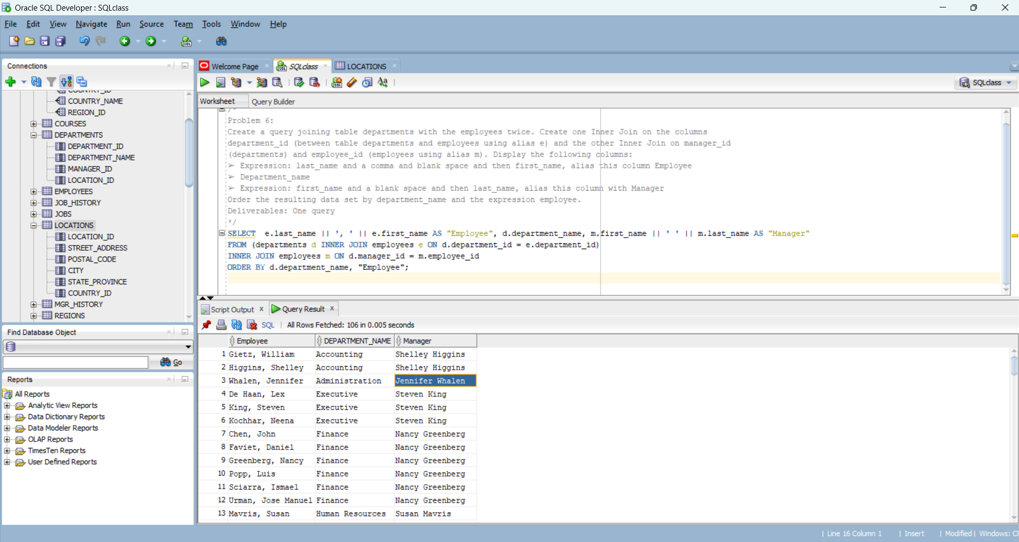

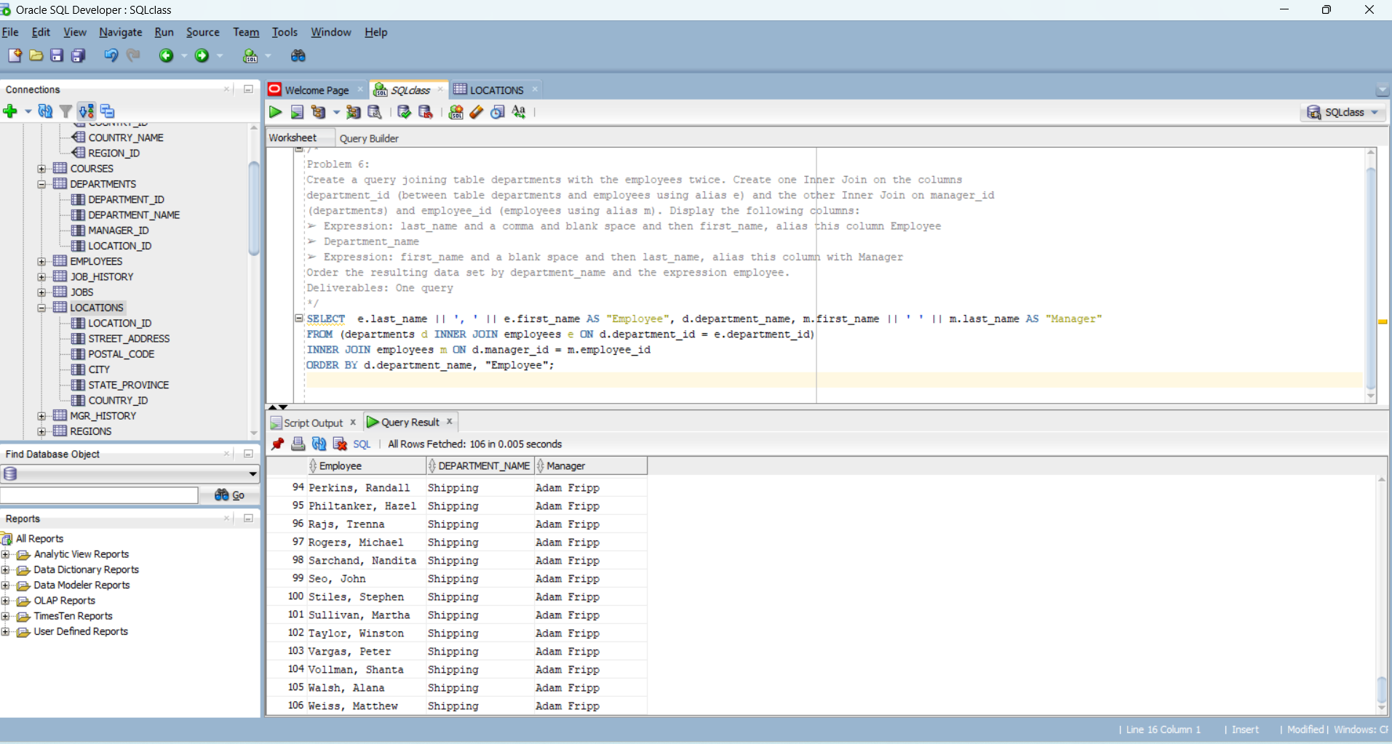

/*

**Problem 7:**

Create a self join using table employees using the join fields manager_id to employee_id. Perform this self join only for

people working in department_id 80. Display the last_name for the manager, the last_name for the employee and the

department_id. Order the resulting data set by the manager’s last_name.

Deliverables: One query

*/

SELECT m.last_name manager_lastname, e.last_name employee_lastname, e.department_id

FROM employees e INNER JOIN employees m ON e.manager_id = m.employee_id

INNER JOIN employees m ON e.manager_id = m.employee_id

WHERE e.department_id =80 AND m.department_id =80

ORDER BY m.last_name;

